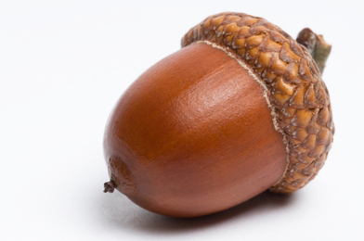 |  | - Christmas 2017

Welcome to our final Acorn’s newsletter for 2017. With Christmas and 2018 just around the corner and nativity rehearsals in full swing, I thought it was the right time to take a minute and bring you all up to date on what the children and teachers have been up to and what is happening on the management side as well.
Our Christmas nativity – ‘The Magical Christmas Jigsaw’ takes place in the Community Centre on Tuesday December 19th at 7pm (pupils should be there by 6.15pm) – everybody is invited so spread the word! €5 on the door per adult and €10 per family. The Parent’s Association will also have their ever-popular calendar for sale on the night.
Christmas holidays begin for all pupils at 12 sharp on Friday December 22nd. School reopens on Tuesday, January 9th as the teachers have a training day for the new primary language curriculum on Monday 8th.
In other news, our numbers on the role this September mean that we will have one less classroom teacher in September ‘18. In advance of the allocation thresholds being published, we understand that we would have had to have had 51 pupils on the role last Sept. 30th to retain the 3rd classroom teacher, unfortunately we had 50 pupils. However, we will continue to have FOUR teachers in the school. 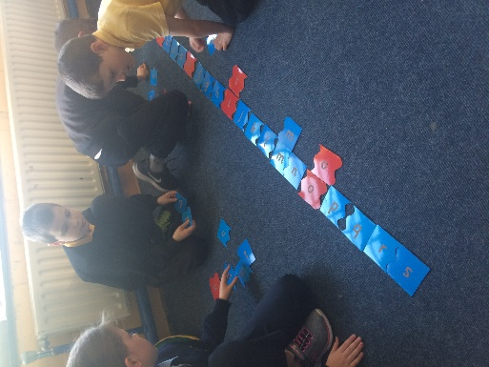
Children engaged in active learning during LLO
Members of the Board of Management and teaching staff will meet with parents in January to address any concerns you may have and to show you how we will use the resources we have to ensure that the quality of education that your children receive is not impacted by this.
In the Summer edition of Acorns I told you that we were working to secure better broadband for the school. Negotiations between Ciaran Moynihan and Rapid Broadband resulted in a much faster FREE broadband service which the teachers have been making full use of.
Funding Delay
We have been waiting for the payment of the Minor Works grant in order for us to carry out a number of maintenance jobs in the school. We are unable to use the tarmac at present as it needs to be power washed to remove a build up of soil and moss which has made it very slippery, something we cannot do until this grant arrives. While it is super that the children get to use the pitch, we are concerned that it will become too soft and wet over the coming weeks. We are keen to have the use of the tarmac as an option. While the Department, only this morning, announced that the grant will be paid we have no date for payment. In the meantime we have to set aside maintenance issues or rely on the generosity of parents to get issues attended to. Many thanks to Sean O’Donovan who painted the senior room and re-positioned the blackbaord for Ms. Courtney and to Ciaran Moynihan who removed and rearranged some built in furniture and continues to be on call for our IT issues. If there is any skill that you have that you feel would be of help to us please call Jackie – I have a list of small jobs that we would be very grateful to get done.
As you are aware we are a Health Promoting School. Last year, and the previous one, Ms. Harrington oversaw the implementaion of the Active Schools initiave – which resulted in the school being presented with our Active Flag. While HPS covers all aspects of health – mental, physical and nutritional – we will be focussing on Healthy Eating in the new year. The HPS committee will survey the pupils about what they like in their lunchboxes. Parents will be asked to comment on the proposed contents of an updated Healthy Eating Policy. We look forward to plenty of yummy lunch ideas and to your support in keeping our pupils healthy and happy.
Assembly
This year we have established a weekly assembly where we celebrate our achievements, exchange news and each class showcases their work. In week 1, we had a fabulous presentation from Ms. Courtney’s class on all types of natural disaster.
The following week Ms. Harrington’s class taught us the provinces and counties of Ireland. Then we had reader’s theatre with Ms Breslin’s gang. 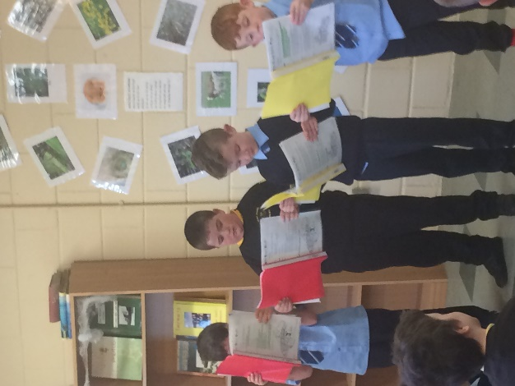
Ms Grenaghan’s class taught us how to make blackberry jam and Mrs Walsh’s troupe read out their fine essays.
Our school Facebook Page is now live. This is separate to the Parent’s page and will be not have a closed audience. We will be looking for your permission to put photos of pupils on this site in a similar fashion to the school website. Both the Parent’s Association and the BOM feel that this is an important method of marketing the school at a very competitive time for numbers.
News from the Junior Room
In the junior room the children have been learning about the history of snow globes! Did you know that an Austrian mechanic named Erwin Perzy accidentally invented the 'Snow globe' while attempting to enhance Thomas Edison's electric light bulb?
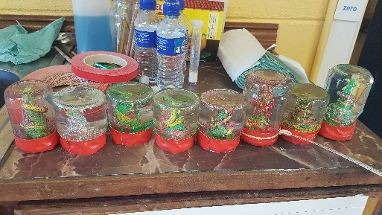
When making our snow globes, we linked maths (3D shapes and estimating height) with Art (3D construction) while also reusing our glass jars for the 3rd and final time. These jars have already been used for sauerkraut and blackberry jam made by the children -all good news for our 6th green flag!
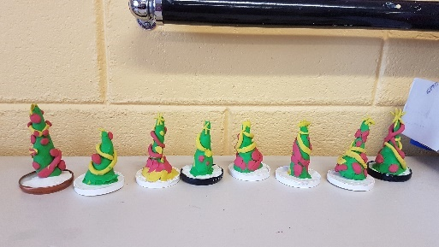
Speaking of our green flag, we have just completed a whole school waste audit. We are encouraging the children to cut down on waste in as many ways as possible- reusing and recycling both in school and at home. Remember, the children will soon be completing a survey on global citizenship - litter and waste, so remember to keep them aware of putting the correct types of waste in the correct bins as well as considering buying some fair-trade products as well as buying local whenever you can.

The Parish Carol Service takes place on Sunday December 17th at 7pm. All pupils from 1st to 6th are asked to take part. It is a lovely evening where all the schools in the Parish come together to celebrate Christmas.
Please download the free Textaparent App from App store or Google Play – it will cut the cost of text messages from 5c each to 0.5c per text which will in turn reduce charges to parents in the coming year.
Every Tuesday our Middle room becomes Chess central. Ms. Harrington facilitates a chess club and class. The children are really enjoying this new challenge and hope to compete against another school later in the academic year. We also had a visit from Mr. Pat Hanrahan from Clare Education Centre last Friday.
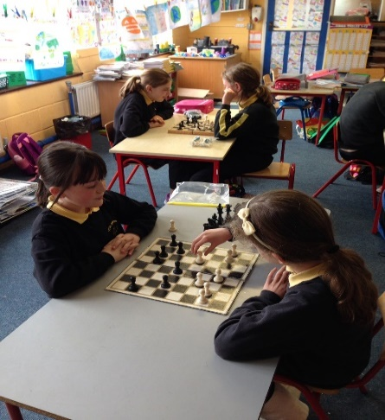
He brought a cool Maths resource that the children of the Senior Room had the opportunity to explore. They really enjoyed the experience and there are plans to use the set that is available to schools from our own Education Centre in Dunmanway.
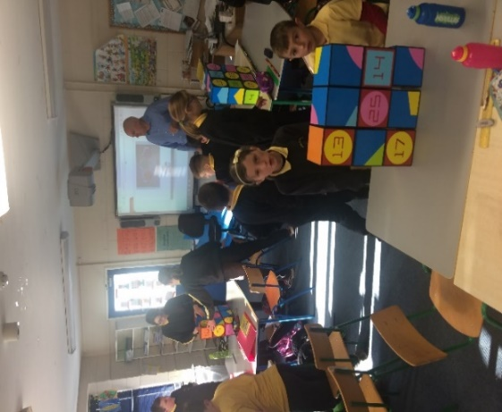
Please keep our Cash for Clobber collection in mind when you are clearing clothes. We are accepting bags on a rolling basis and they can be dropped to the school as you fill them. Shoes are accepted but must be in pairs and separate to fabric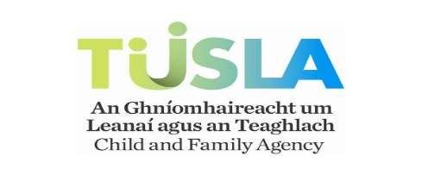
From now on when your child is absent we will need a signed note stating whether the absence was due to sickness, holidays or family business. This is to keep us in line with TUSLA guidelines for recording school attendance. There is a small form in the back of the homework journal that you may use for this or a written note to the class teacher will do too. If your child is absent and we do not receive a note you will be asked to send one in. There is no need to ring the school for an absence as we need a signed note.
We are collecting for Clonakilty Red Cross and Cork Penny Dinners again this year. Your generosity to date is great. There are a couple of weeks left. Padraig from the Clonakilty Branch will then collect the items and give the children a look at the inside of the Red Cross ambulance. You have already donated a large number of items to this year’s collection. There are two weeks left: 4th – 8th Dec and 11th to 16th Dec. Here is a reminder of what Penny Dinners would like during the last fortnight.
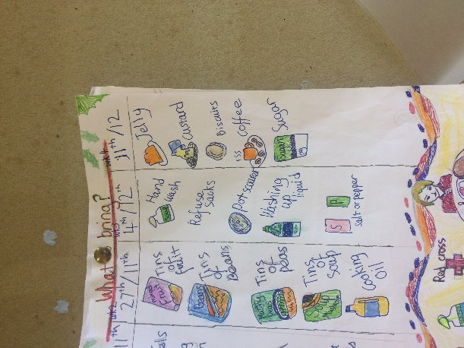
Many thanks to the new Parent’s Association committee for another wonderful Halloween Disco. There were ghosts and ghouls, dead brides and politicians. There was worm infested jelly and wild dancing through cobwebs and balloons. The PA followed in the footsteps of their predecessors and put on a great event for the kids.
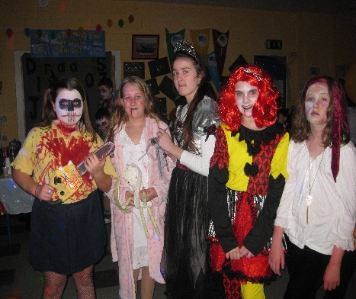
The Ghouls of 6th class! YIKES!!Our school website www.darrarans.ie contains updates and school information. We endeavor to keep it updated and relevant. There is an email form that can be used to contact the school as this will be delivered to the school email account.
The annual swim is a great social event in the school calendar and the main fundraiser undertaken by the Parent’s Association. This year it will take place from the pier at 12pm on St. Stephen’s Morning. Sponsorship cards will be distributed to each family very shortly.
One of the first events that the children and staff undertook this year was to run the distance from Dublin to London. We really enjoyed the challenge and the pupils are making noises about racing the teachers to Moscow next!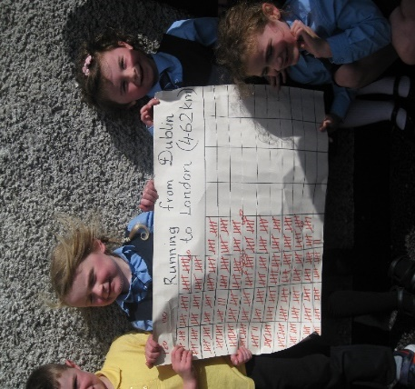
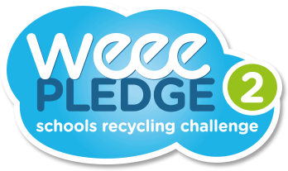
Don’t throw out all those Christmas batteries. We are joining the Weee Pledge. Every box of used batteries will raise €5 for the LauraLynn childrens’ Hospice.

